Hydrogen Storage

**LH2 specifications**

gravimetric energy density = 142 MJ/kg

volumetric energy density = 10.1MJ/kg

density = 71 kg/m3

**Benefits and Challenges**

* Stored in liquid form at a cryogenic temperature of -253C (-423F), hydrogen is lighter than conventional Jet-A1 kerosene for a given amount of energy.
* Liquid hydrogen requires larger tanks because of its low density compared with jet fuel.

**Storage options**

* Compressed Hydrogen Storage
* Cryogenic Hydrogen Storage
* Hydrogen Storage with adsorbents

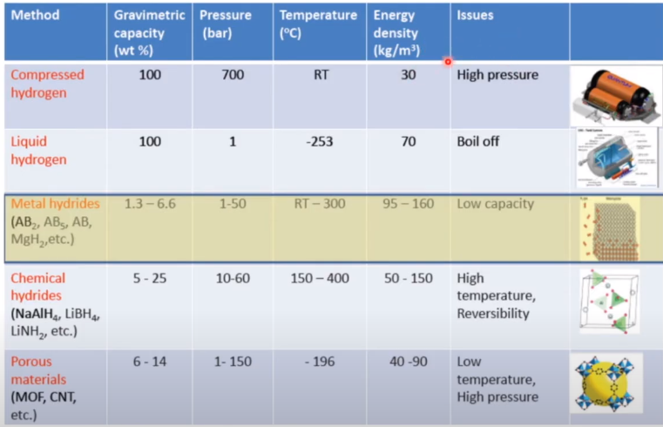

1. **Gaseous form**

* Compressed hydrogen is shipped in tube trailers at pressures up to 3,600 psi (about 250 bar).
* 4 tanks carrying 150kg of gaseous hydrogen with an 8500L capacity. These tanks take the shape of a tube rather than a sphere which means they can be easier to integrate to a fuselage. Weight of 1 tank = 2485 kg.
* Hydrogen can be compressed upto 700 bar.
* A tube trailer with steel cylinders can store up to 25,000 liters of hydrogen compressed to 200 bar (Wystrach GmbH, 2017a), which amounts to around 420 kg of hydrogen.
* With high pressure hydrogen tanks made of stainless steel, we see hydrogen embrittlement.

1. **Liquid form**

* LH2 takes less space than gaseous hydrogen and is stored in pressurized and thermally insulated containers. This pressure must be carefully selected to prevent the hydrogen from exploding (burst pressure).
* The cryogenic hydrogen is to be stored in specially insulated vessels at (-) 252.880C. The energy required to liquefy hydrogen (gas at 300oK and 1 bar pressure) is about 47 MJ / kg of hydrogen.
* Main challenges include the logistics in transporting it to the aircraft as well as boil off issues.

1. **With adsorbents**

* Hydrogen can be stored by mixing it with other materials like adsorbents, interstitial hydrides etc.
* But if the hydrogen is to be used in a fuel cell, then recovering the hydrogen from the mixture will be another task consuming energy (liquefaction).

